Synod of Strategic Prophecy
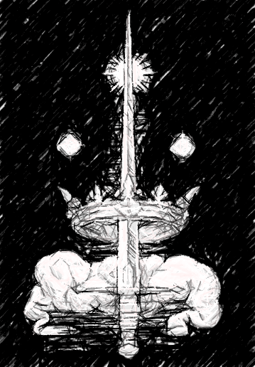
The Valley of the Word serves as both the headquarters and spiritual home of the Synod of Strategic Prophecy. Its location remains one of the most closely guarded secrets in all of Christendom – a hidden temple nestled deep within a remote European gorge, where the very stones help to amplify the echo of God’s words.
The floor of the valley itself forms the cloister of the temple, covered with arrays of dishes, antennae, radio telescopes and listening posts, all straining towards the heavens. The cryptic messages received are processed through great difference engines, designed by the Synod's Ordained Engineers, then translated, analysed and studied by scholar monks from the many monasteries, each specialising in their own area of divine interpretation.

At the very heart of the valley stands the Gate of God, a colossal steepled tower that serves as the conduit for receiving the Holy Words yet remains incomplete. Each year it rises higher, its maze-like network of antennae, loudspeakers and receptors emitting a hymn of every language ever spoken.
The Observers emerge from their cells only for the most critical missions, when the Synod elders have received divine guidance. Whether reinforcing a collapsing front or eliminating heretic assassins who have infiltrated the heartlands of Christendom, in times of need the Synod Elders even send out whole Retinues with their Warriors to ensure whatever Prophecy was uncovered.
In recent years the War Cardinal has voiced criticism of the Synod, likening their tower to the hubristic act of Babel. To strengthen their Position in Clergy, the Synod Elders have begun sending out whole Retinues of Warriors to make a visible and felt impact at the front lines of the Conflict.

Synod of Strategic Prophecy

Warband Creation
You have 700 to recruit a Synod Warband for a campaign (> see Starting a Warband). The Synod of Strategic Prophecy are Faithful.
When you create a Synod Warband choose one of three Frequencies. Some Models have different Abilities depending on what Frequencies your Synod Warband is currently aligned with.
Freq 1 | Freq 2 | Freq 3
Debuff | Mobility | Killing

Special Rules
The following special rules apply to the Synods Warbands (including any Synods Variant Warbands):
- Strategic Prophesizing: Before the start of each turn, shuffle your Prophecy Deck and draw as many Prophecy Cards as indicated in the Table blow. Secretly select which cards to play for the turn and return the unchosen cards to your deck.
When a Prophecy card resolves and your prediction was correct gain a Prophecy DICE.
Games Played | Prophecy Cards
1-2 | Draw 4 play 2
3-5 | Draw 5 play 3
6-9 | Draw 7 play 4
10+ | Draw 8 play 5

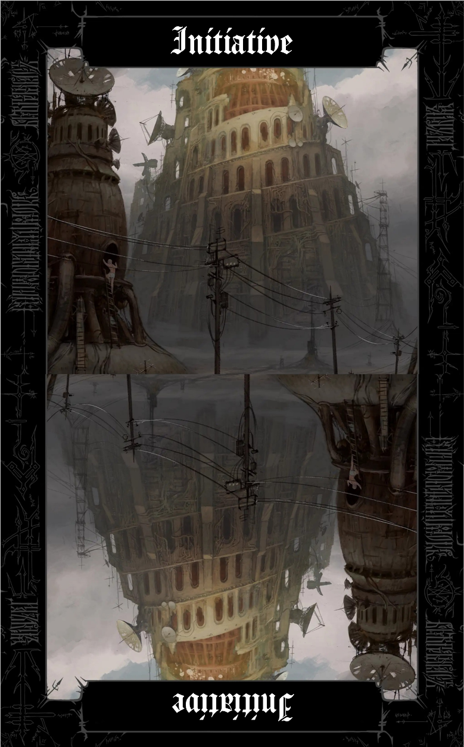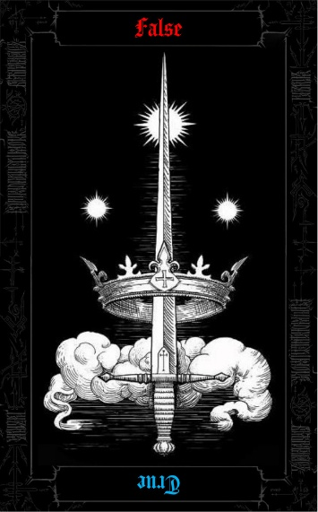
- Prophecy Cards:
Each card in your Prophecy Deck contains a prediction. The orientation you choose when laying it down determines which prediction you are making; the side that is closer to the battlefield is the prediction you are making
(Most Cards get laid out in secret some cards have the restriction that they have to be played out openly
--true/false side visible--)
- Prophecy Dice
When you gain a Prophecy Dice, roll a D6 immediately and set it aside, keeping the face-up result. Before any model (friendly or enemy) makes a Success Roll, you may expend one of those set aside DICE to replace one of the physical dice about to be rolled with the exact value of your expended die.
(Injury rolls are not Success rolls | If a roll is rerolled with the Eye of God Ability any added Prophecy Dice is retained through the reroll)

Armoury Tables
The Synod of Strategic Prophecy can have the following Battlekit. Battlekit with a bullet point [•] is unique to Synod, and its rules can be found in the Synods Battlekit section after the Armoury. (▶ see Battlekit in the Trench Crusade Digital Rulebook).
Ranged Weapons
•Receptor Staff | Limit: 1 | 3
Automatic Pistol | Limit: 3 | 20
Automatic Rifle | Bayonet Lug, Limit: 1 | 40
Automatic Shotgun | Bayonet Lug, Shield Combo, Limit 2 | 12
Bolt-Action Rifle | Bayonet Lug | 10
Flamethrower | Limit: 3 | 30
Grenade Launcher | Limit: 2 | 30
Machine Gun | Limit: 1 | 50
•Heavy Machine Pistol | Shield Combo, Limit: 1 | 35
Pistol |  | 5
Semi-Automatic Rifle | Bayonet Lug | 12
Shotgun | Bayonet Lug, Shield Combo | 10
Sniper Rifle | Limit: 3 | 35
Submachine Gun | Bayonet Lug, Shield Combo, Limit: 2 | 30
Melee Weapons
Bayonet | Shield Combo | 2
Great Hammer/Maul |  | 10
Great Sword/Axe |  | 12
•Angel Shard Spear | ELITE only, Limit: 1 | 25
Polearm | Shield Combo | 7
Sword |  | 4
Trench Club |  | 3
Trench Knife |  | 1
Grenades
Frag Grenade |  | 7
Incendiary Grenades |  | 10
Shields
Trench Shield |  | 10
Armour
Reinforced Armour | ELITE and Heavy Infantry only | 40
Standard Armour |  | 15
Equipment
•Oculus Helmet | Headgear | 2
•Twice Blessed Bullets | Limit: 2 | 10
Binoculars | ELITE only | 10
Combat Helmet | Headgear | 25
Field Shrine |  | 2
Gas Mask |  | 5
Medi-kit |  | 5
Mountaineer Kit | Limit: 4 | 3
Musical Instrument | Limit: 1 | 15
Shovel |  | 5
Troop Flag |  | 1

Your Faction Battlekit
The following Battlekit items are unique to the Trench Pilgrims Warband. Rules for all other items are in the standard Battlekit section (▶ see Battlekit in the Trench Crusade Digital Rulebook).
Twice Blessed Bullets| 10 limit: 2, (no sniper Rifle)
“Manufactured and in the Workshops of the Valley of the Word these Munitions are sanctified in small Shrines at the Base of the Gate of God”
Type | Range | Keywords
Equipment |  | AMMUNITION (Negate CRITICAL Keyword)

- Sanctified: A success Result of 9 or higher is converted into a critical hit.
Angel Shard Spear| 25 | Limit: 1
Relics made from Shards found at Angel Sightings
Type | Range | Keywords
2-Handed | Melee | +1 INJURY DICE

- Cast Down the Fallen: This weapon has the IGNORE ARMOUR Keyword if the target is Down.

Heavy Machine Pistol| 40 | Limit: 2
A Heavy Short range suppression gun
Type | Range | Keywords
2-Handed | 20” | AUTOMATIC (3), HEAVY, SHOTGUN

- Big gun: You cannot equip Melee Weapons while having this equipped.

Ark of the Signal| 5 | Limit: 1
Type | Range | Keywords
2-Handed | Special | DEPLOYABLE, HEAVY, HELD
An Ark of the Signal is represented by a terrain piece that is about 1” high and which is mounted on a 25mm base. It is Impassable terrain.
- Place Ark ACTION: Deploy the Ark of the Signal anywhere within 1” of the model. Once deployed, the model that had the Ark is not considered to be carrying it for the rest of the game.
- Destroying an Ark of the Signal: A player can choose the Ark of the Signal as the target for a Melee Attack of any type. If the attack is a success or a Critical Success, the Ark of the Signal is removed from the battlefield.
The following Frequencies apply to any Enemies within 8” of a deployed Ark of the Signal:
  - Freq 1: Enemy models within 1" of a SYNOD model cannot take the Stand-Up ACTION.
  - Freq 2: The Synod player may reroll any roll of a 1 by any model within 8" of the Ark (friendly or enemy). This rerolled result stands.
  - Freq 3: Add +1 INJURY MODIFIER to Injury Rolls made against enemy models within 8" of the Ark.
Oculus Helmet| 2 | Elite and Observer Initiative only
The valley is home to all manner of workshops and foundries which produce the armaments of the Observers. The most important of these is the Calefactory where the wondrous Oculus helmets are created out of pure Orichalcum, each one a unique masterpiece of engineering and craftsmanship.
Type | Range | Keywords
Helmet

- Eye of God: You can re-roll failed Success Rolls and Risky Success Rolls for a Model with this Helmet. If you do so and any of there-rolled dice show a 1, then the roll is treated as a Failure, the Observer is taken Down, and their Activation immediately ends.

Receptor Staff| 3 | Prophetic Tactician only
A simple Metall Rod blessed and thus able to amplifying the Voice of God that even heretics may witness it’s glory.
Type | Range | Keywords
1-Handed | 18” | +1 INJURY DICE, ASSAULT

- Prophetic Imperative: When laying out your Prediction Cards at the start of the Turn point at one and say it is blessed. When it resolves if you were correct gain 2 Prophecy DICE, but if you are wrong the Enemy gets a Prophecy DICE.

Panzerschreck| 2 |
These shoulder-fired weapons launch a rocket with an explosive warhead. They are a recent invention, and thus expensive and difficult to manufacture.
Type | Range | Keywords
Special | 24” | IGNORE ARMOUR, RELOAD

- Disposable Rocket: If a model that has been hit by a Panzerschreck is not taken Out of Action by the Injury Roll, it is blown D6” in a straight line directly away from the attacking model. This can trigger Opportunity attacks.
(You can only use this Weapon once per Battle.)

Prophetic Revelation| 1 |
It is difficult to readjust all the equipment. Thus a new Frequency can only be received with great consideration and effort.
Type | Range | Keywords
Event |  | CONSUMABLE

- Prophetic Revelation: Change the Frequency you chose when creating this Warband in the Quartermaster Phase.

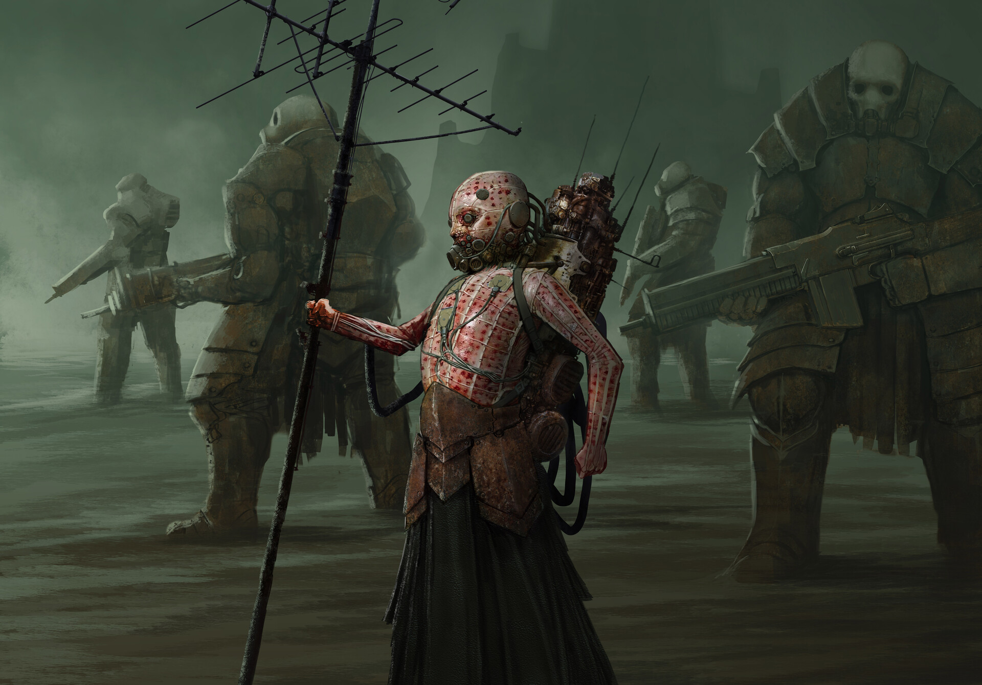
Elite Warband Entries:
The Attuned
0-1 Prophetic Tactician– Cost: 80 
A Synod Warband must include 1 Prophetic Tactician
Beneath the central tower, deep within the Valley of the Words bedrock, dwell the Prophetic Tacticians, the most precious assets of the Synod. These gifted children are surgically, genetically, and chemically altered to make them perfectly suited to their role. They are equipped with strange and esoteric equipment that allows them to hear the word of God.
For reasons the Synod elders still cannot begin to explain, some Tacticians undergo Corporal Mitosis during their service. From the flesh of the host -most often the torso or abdomen- a second body slowly buds and grows. When the new body reaches the size of the original, the two separate. Though they act autonomously, they seem to house the same soul. One cannot survive without the other, but neither can truly die alone.
Movement | Ranged | Melee | Armour | Base
6”/Infantry | +1 DICE | +1 DICE | 0 | 25 mm

Battlekit |  | A Prophetic Tactician is always equipped with an Oculus Helmet and can have any Battlekit that is not a Grenade from the Synod Armoury Tables.
Abilities | - Corporal Mitosis: A Prophetic Tactician is deployed as two identical models. They are the same model in all respects, they share BLOOD MARKERS, their Active and Down state, and all Actions. Each Action may only be taken once per Activation across both bodies. The exceptions are Move, Dash, and Charge ACTIONS, which each body may take independently.  - Sharing Gods Voice ACTION: Take a Success Roll. On a Success or Critical Success, select one enemy model within 12" and in Line of Sight. That model is taken Down.  The following Frequencies can apply to a Prophetic Tactician:  - Freq 1: Add -1 DICE to all Action Rolls made by enemy models within 8" of a Prophetic Tactician  - Freq 2 ACTION: Select one friendly model within 12". That model may immediately take a Move or Charge ACTION. It may also take a Dash ACTION but must make the Dash S uccess Roll as normal. If the Dash roll is a Failure, that model does not move and the Prophetic Tactician's Activation immediately ends.  - Freq 3 ACTION: Take a Success Roll targeting one enemy model within 12" and in Line of Sight. On a Success or Critical Success, double the number of BLOOD MARKERS next to that model. If the target has no BLOOD MARKERS, place 1 BLOOD MARKER next to it instead.
Keywords |  | SYNOD, ELITE, LEADER, WEAK, TOUGH
WEAK Keyword: 1-Handed Weapons carried by this model are treated as 2-Handed. 2-Handed Weapons carried by this model gain the HEAVY Keyword. This model cannot be equipped with Battlekit that has the HEAVY Keyword.
(note: getting strong negates both keywords)


0-2 Synod Observer– Cost: 90
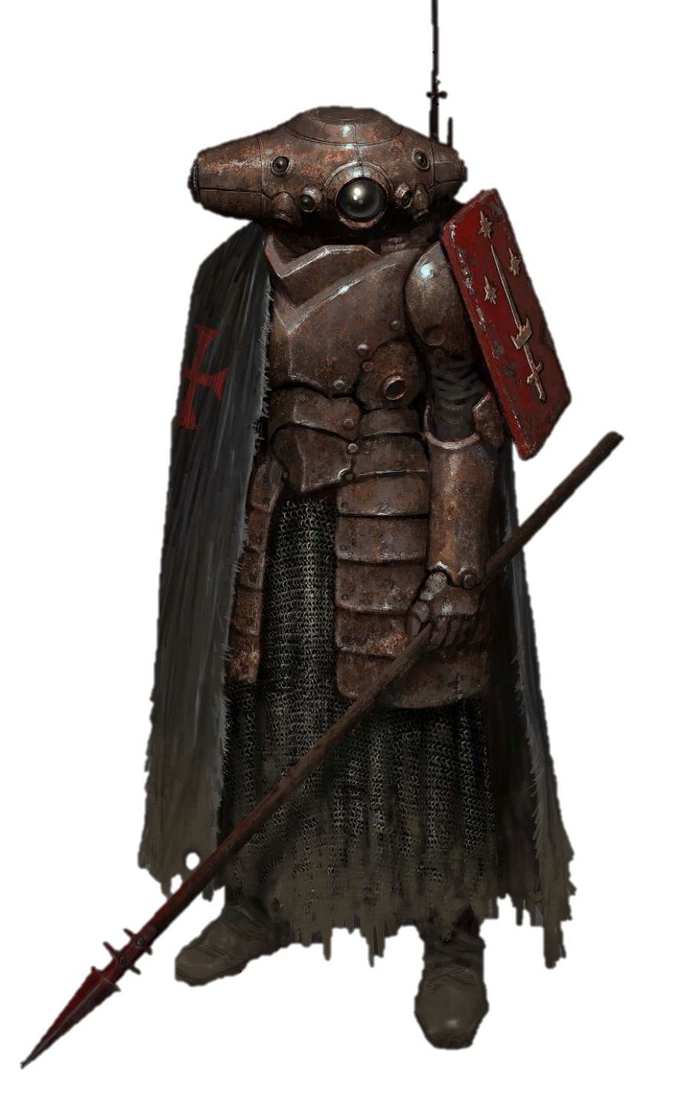
This order of warrior monks lives in absolute solitude, honing their minds and bodies to become living weapons of the Hand of God. Once a soldier joins the order, they rarely leave the Temple of the Word, the sole exception being when they are summoned to the battlefield, where their unique abilities can decisively shift the balance in favour of the Faithful. The slightest disturbance in their prayers or training could sever their connection to the Lord of all Creation. Thus, the days and nights of the Observers are spent in secluded, cloistered cells, when not practicing their rigorous martial and mental disciplines.
Movement | Ranged | Melee | Armour | Base
8”/Infantry | N/A | +2 DICE | 0 | 32 mm

Battlekit | An Observer always can have any Battlekit from the Synod Armoury Tables.
Abilities | - Eye of God: You can re-roll failed Success Rolls and Risky Success Rolls for an Observer. If you do so and any of there-rolled dice show a 1, then the roll is treated as a Failure, the Observer is taken Down, and their Activation immediately ends.  - Lightning Speed: Any two-Handed Melee weapon the Observer carries has the CLEAVE 2 and CUMBERSOME Keywords  - Temporal Fugue: Add -1 DICE to rolls for Ranged Attacks and Melee Attacks that target an Observer.  - Voice of God: RISKY ACTION: this Ability can only be attempted by One Synod Model per Turn.
Keywords | SYNOD, ELITE, NEGATE SHRAPNEL, NEGATE GAS

0-1 Ark Bearer– Cost: 100
The tower is circled day and night by processions of the Arks of the Signal. The bearers of these arks, which are fashioned after the Ark of the Covenant and integrated with sophisticated radio arrays, are permanently connected to them with synaptic cables and chemical tubes. They labour ceaselessly to locate the optimal position of the ark they bear on each given day so that the Synod can capture the most elusive words of God, beyond the reach of the main arrays of the tower.
Movement | Ranged | Melee | Armour | Base
6”/Infantry | -1DICE | +2DICE | 0 | 32 mm
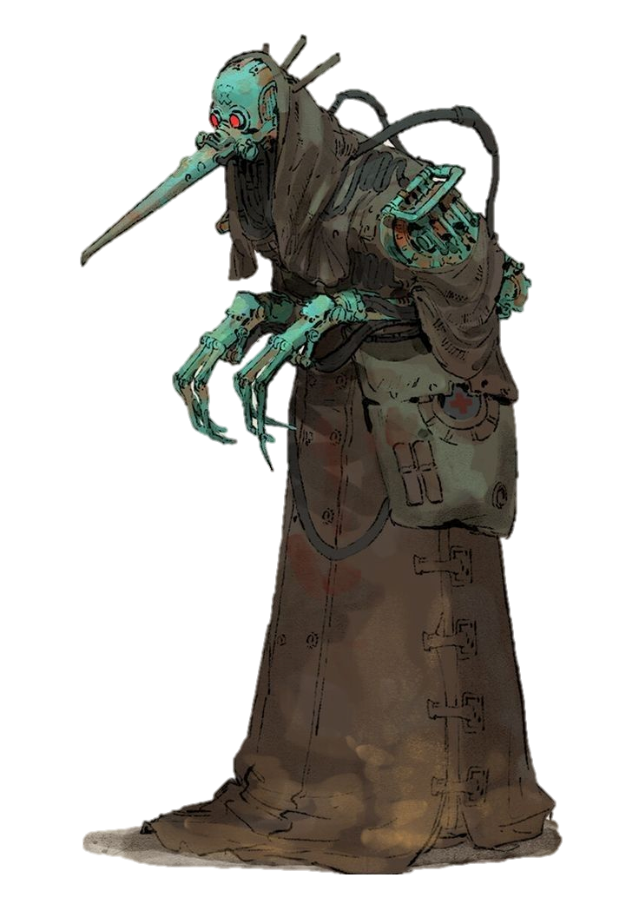
Battlekit | An Ark Bearer can have any Battlekit from the Synods Armoury Tables.
Abilities | - Ark Bearer: At the start of a match, an Ark Bearer always carries one Ark of the Signal. The Ark of the Signal occupies 1 Hand rather than 2 while carried by an Ark Bearer. Once the Ark is deployed, that hand is free.
Keywords | SYNOD, ELITE, STRONG, TOUGH
Ark of the Signal
Arks, fashioned after the Ark of the Covenant and integrated with sophisticated radio arrays.
Type | Range | Keywords
2-Handed | Special | DEPLOYABLE, HEAVY, HELD

An Ark of the Signal is represented by a terrain piece that is about 1” high and which is mounted on a 25mm base. It is Impassable terrain.
- Place Ark ACTION: Deploy the Ark of the Signal anywhere within 1” of the model. Once deployed, the model that had the Ark is not considered to be carrying it for the rest of the game.
- Destroying an Ark of the Signal: A player can choose the Ark of the Signal as the target for a Melee Attack of any type. If the attack is a success or a Critical Success, the Ark of the Signal is removed from the battlefield.
The following Frequencies apply to any Enemies within 8” of a deployed Ark of the Signal:
  - Freq 1: Enemy models within 1" of a SYNOD model cannot take the Stand-Up ACTION.
  - Freq 2: The Synod player may reroll any roll of a 1 by any model within 8" of the Ark (friendly or enemy). This rerolled result stands.
  - Freq 3: Add +1 INJURY MODIFIER to Injury Rolls made against enemy models within 8" of the Ark.

Troop Warband Entries:
Servants of the Signal
Serf/Receptors – Cost: 20
Any soul that enters the Valley of the Word without divine sanction pays the price of lifelong servitude. Disposable servants and labourer.
To better capture the Divine Frequencies that the Temple strains to receive, select servants have their brains partially replaced with receivers attuned to the Word of God.
Movement | Ranged | Melee | Armour | Base
6”/Infantry | -1 DICE | +0 DICE | 0 | 25 mm
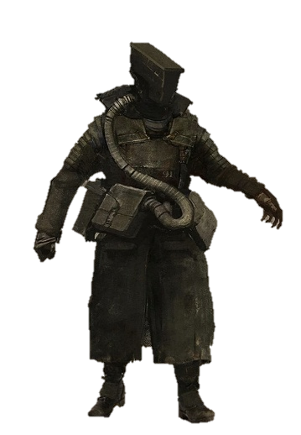
Battlekit | A Serf/Receptor can have any Battlekit from the Synod Armoury Tables.
Abilities | - Sacrificial Bodyguard: When a SYNOD model within 1" is the target of a Ranged or Melee Attack, a Receptor can choose to intercept the hit. If it does, make an Injury Roll for the Receptor instead of the original target. A Down result is converted to an Out of Action result. This ability cannot be used against attacks with the BLAST Keyword.  When recruiting a Serf, you may permanently replace Sacrificial Bodyguard with Frequency abilities, making them a Receptor:  - Freq 1: While this model has not Activated this turn, add -1 DICE to Ranged Attack rolls targeting it and SYNOD models within 1".  - Freq 2: Receptors suffer an Out of Action result instead when they go down at any point. Add +1 DICE to Dash ACTIONS and Melee Attack ACTIONS made by this model.  - Freq 3 ACTION: Make a Success Roll. On a Success or Critical Success, remove this model from play and make an Injury Roll with +1 INJURY DICE for every model within 2".
Keywords | SYNOD, WEAK  WEAK Keyword: 1-Handed Weapons carried by this model are treated as 2-Handed. 2-Handed Weapons carried by this model gain the HEAVY Keyword. This model cannot be equipped with Battlekit that has the HEAVY Keyword.  (note: getting strong negates both keywords)

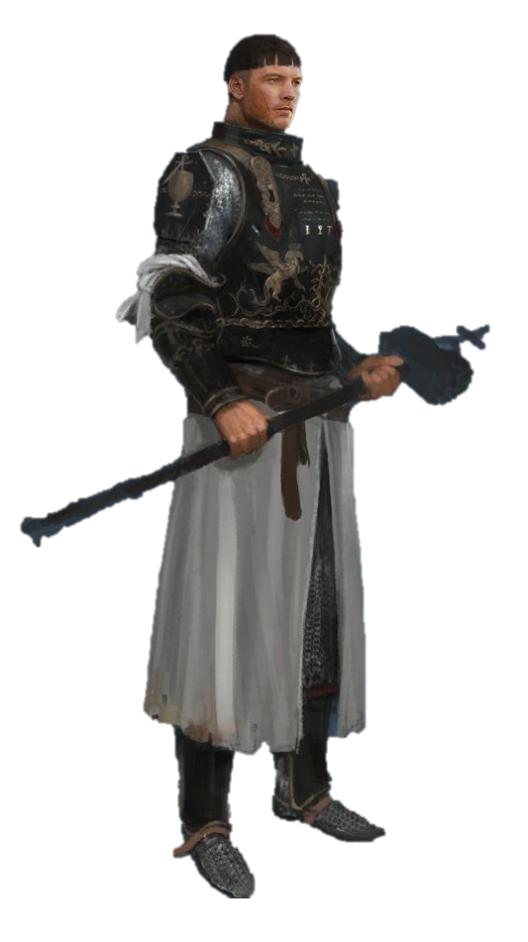
Observer Initiate – Cost: 45
To be accepted into the ranks of the prestigious Observers, an aspirant must forge a direct and personal connection with God. Many promising Initiates seek that connection on the hectic battlefield, accompanying their idols into the fray. They cherish these final years of unfiltered existence, knowing that should they prove worthy, they will one day don the Oculus Helmet and with it, trade the noise of the living world for the all-encompassing Voice of the Divine.
Movement | Ranged | Melee | Armour | Base
7”/Infantry | +0 DICE | +1 DICE | 0 | 25 mm

Battlekit | An Observer Initiate can have any Battlekit from the Synod Armoury Tables.
Abilities | - Lightning Speed: Any two-Handed Melee  weapon the Observer Initiate carries has the CLEAVE 2 and CUMBERSOME Keywords
Keywords | SYNOD

0-1 Combat Medic – Cost: 65
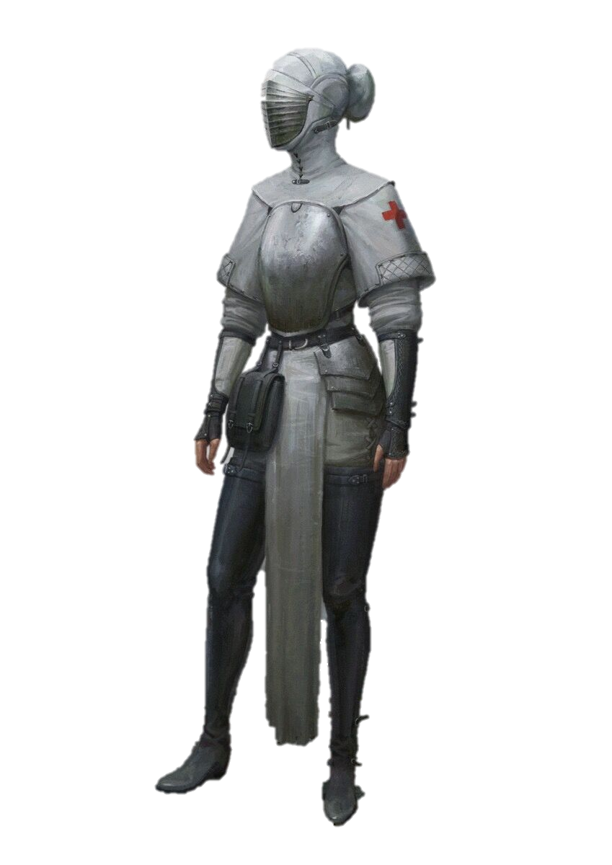
Human bodies are fragile things when exposed to the raw power of the Divine. The Synod therefore maintains a cadre of Sisters of Saint Cosmas.
Movement | Ranged | Melee | Armour | Base
6”/Infantry | +0 DICE | +0 DICE | -1 | 25 mm

Battlekit | A Combat Medic always has Standard Armour, a Gas Mask, a Medi-kit, and a Misericordia (▶ see Battlekit in the Trench Crusade Digital Rulebook). The Injury Modifier for the Armour is included in the model’s Profile above. They can also have any Battlekit from the Synod Armoury Tables, apart from Armour.
Abilities | - Expert Medic: Add +2 DICE to the Risky Success Roll when a Combat Medic carries out a Treat ACTION with their Medi-kit.  - Finish the Fallen: Due to their knowledge of anatomy and physiology, medics are experts at inflicting debilitating injuries and excruciating pain. Add +1 INJURY DICE to Injury Rolls for Melee Attacks made by a Combat Medic if the target is Down and does not have the BLACK GRAIL or DEMONIC Keywords.
Keywords | SYNOD

0-4 Synod Engineer – Cost: 50
The Ordained Engineers of the Synod spend their lives in the workshops and foundries beneath the Valley of the Word, maintaining the vast arrays of the Gate of God. To them the recovery and maintenance of holy machinery is of a much higher Priority than protecting any living Soul.
Movement | Ranged | Melee | Armour | Base
6”/Infantry | +1 DICE | +0 DICE | 0 | 25 mm

Battlekit | A Synod Engineer can have any Battlekit from the Synod Armoury Tables.
Abilities | The following Frequencies can apply to a Synod Engineer:  - Freq 1: A Synod Engineer ignores the -1 DICE penalty for shooting at Long Range.  - Freq 2 ACTION: Make a Success Roll. On a Success or Critical Success, move all SYNOD models with the WEAK Keyword within 8" up to 3". This move cannot take them to within or out of 1" of an enemy model.  - Freq 3: Synod Engineers gain the INFILTRATOR and SKIRMISHER Keyword.
Keywords | SYNOD
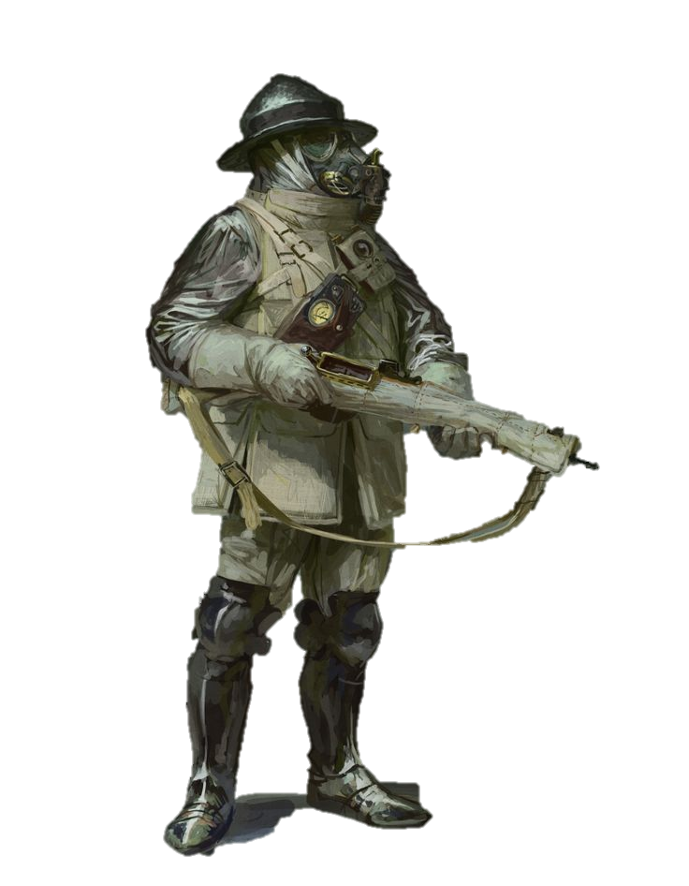
0-3 Sanctified Heavy Infantry– Cost: 95
Clad in heavy Orichalcum battle-plate they are given detailed prophecies before each battle. Visions of the Battle ahead aiding them in leading their shots to never hit their brethren even when they are closely entangled in melee combat. So, they wade through artillery bombardments laying down devastating suppressing fire on the enemy.
Movement | Ranged | Melee | Armour | Base
6”/Infantry | +1 DICE | +0 DICE | -2 | 40 mm
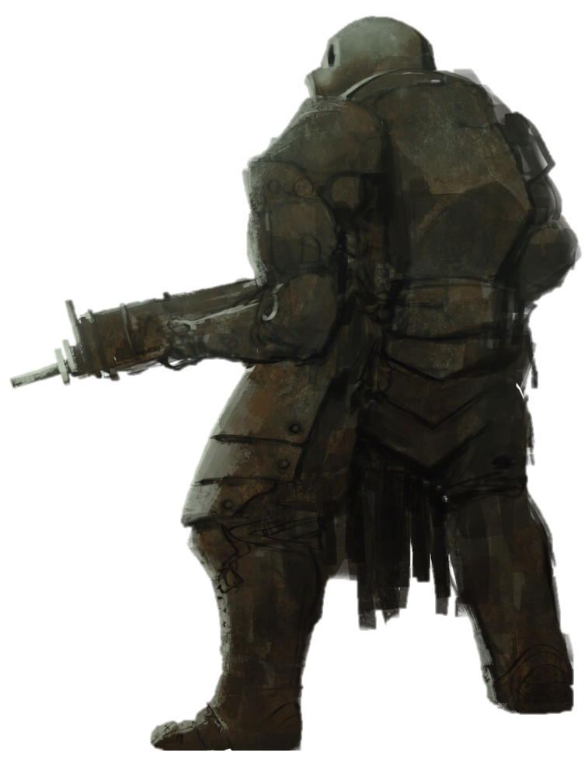
Battlekit | A Sanctified Heavy Infantryman is always equipped with Reinforced Armour and can have any Battlekit from the Synod Armoury Tables.
Abilities | - Prophetic Aim: Discard 1 Prophecy Dice, this turn when targeting an enemy in Melee combat add +2 to the result when determining if you hit your ally or the Enemy  The following Frequencies can apply to a Sanctified Heavy Infantry:  - Freq 1: Add -1 INJURY DICE to Injuries caused by Weapons with the BLAST Keyword and gain the NEGATE FIRE, GAS and SHRAPNEL Keywords.  - Freq 2: Add +1 DICE to Dash ACTIONS made by a Sanctified Heavy Infantryman, but their Weapons gain the RELOAD Keyword  - Freq 3: When a Melee Attack inflicts a Blood Marker on the target, push them 2" directly away. A Sanctified Heavy Infantryman's Ranged Weapons gain the ASSAULT Keyword.
Keywords | SYNOD, NEGATE HEAVY

Prophecy Cards
These are the Prophecies featured on the Prophecy Cards
# | Name | Upright | Restriction
1 | Initiative | Synod activates first | If Synod decides, can only be scored turn 2 onwards, when predicting false
2 | Vanguard | Enemy's first activation is an Elite
3 | Aim | Enemy's first Attack succeeds
4 | Skill | Enemy's first non-Attack Action succeeds
5 | First Blood | First model to lose Tough or go OOA is Enemy
6 | Retreat | The first Retreat to leave Melee.
7 | Charge | Synod charges first this turn
8 | Rearguard | Enemy's last activation is an Elite
9 | VP | Synod Scores more VP this Turn | Must be played openly
10 | Glory | Synod scores mor Glorious Deeds this Turn | Must be played openly
11 | Priority | The first enemy Ranged Attack of the turn that has at least two eligible targets chooses the closest eligible model.
12 | Emperor | The enemy Leader ends their Activation touching an ally’s base | Must be played openly
13 | Entrenched | The first enemy Model who starts Activation touching terrain ends their Activation touching terrain

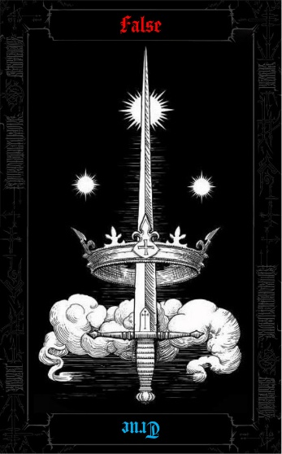
- Prophecy Cards:
Each card in your Prophecy Deck contains two predictions. The orientation you choose when laying it down determines which prediction you are making; one is readable when Upright, the other when Reversed.
(Prophecies like the Initiative Prophecy can of course only be played when the enemy is the one making the Decision this Turn)

